Boss Slicer SL-2 .tsl files decoded

The Boss Slicer SL-2 can be connected to a PC via USB. The Boss Tone Studio software can then be used to import and export collections of patterns called Live Sets as .tsl files. At the time of writing Boss have not provided a pattern editor.

This document is a work in progress describing how patterns can be edited. The authors assumes no responsibility or liability for any errors or omissions etc.

Simple GUI
I’ve had a go creating a simple GUI for Windows using pySimpleGUI (which is an incredibly good tool).

- Download simple.zip from https://drive.google.com/file/d/1eS_InVvJDODqKqgTVF772JYwf1O6nTQq/view?usp=share_link and unzip
- Keep the simple.exe and template.tsl in the same folder (it’s not smart enough to spot it’s missing the template.tsl file atm)
- Run simple.exe, mess with the parameters and press “Write” when you’re done
- Import the output .tsl file into Boss Tone Studio to test out your pattern.

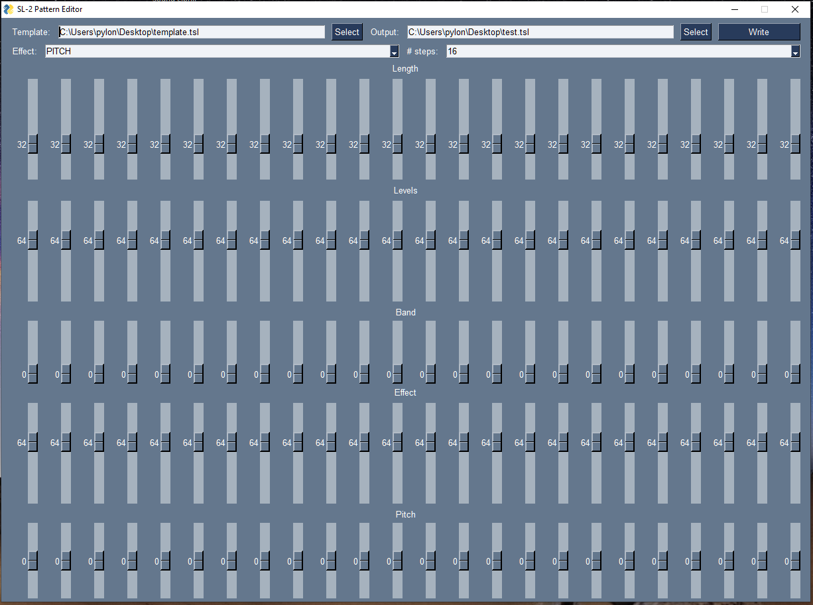

Customising patterns a bit more manually
Suggested process for creating custom patches:
- Launch Boss Tone Studio for SL-2 and create a live set containing a single pattern that is closest to what you are hoping to achieve.
- Export the live set to file, this will save a .tsl file to your PC
- Copy and paste the contents of the .tsl file into JSONMate and edit data using the notes below as a guide.
  - For mono effects JSONMate makes it simple to copy e.g. PATCH%SLICER(1) data to PATCH%SLICER(2).
- Copy and paste the modified JSON back into your .tsl file
- Import this .tsl file back into Boss Tune Studio for SL-2 and preview the pattern.

Ideas
- Can I find where the Boss Tone Studio app read/writes .tsl files on the PC? If I edit these, do the changes take effect immediately allowing a very quick turnaround of edits.
- Simple GUI to edit .tsl files
  - https://pypi.org/project/pysimplegui-exemaker/
  - Reset slider values: https://github.com/PySimpleGUI/PySimpleGUI/issues/1937
    - if event == 'Reset':
      - window['slidey'](1)
  - https://www.pysimplegui.org/en/latest/call%20reference/
    - [sg.FileBrowse(button_text = "Browse",)]
    - [sg.FileSaveAs(button_text = "Save As...",)]

TSL files
The .tsl files use the JSON file format and contain:

Header info
name: Preset Patches
formatRev: 0001
device: SL-2

Data array
A data array consisting of up to 88 elements each representing a single pattern (8 types, 11 variations). Each pattern consists of a memo and a paramSet.

memo
memo: null
isToneCentralPatch: true - this value is set to true even for third-party livesets (e.g. McRocklin's).

paramSet
The paramSet consists of 17 elements which themselves seem to contain Hex named PATCH%<Name>.

I suspect that the parameters with names ending "(1)" and "(2)" indicate left and right output channels.

The Boss GT-1000 Parameters Guide describes the parameters used to control Boss effects so may provide clues to how the SL-2 is controlled.

The Boss MD-500 Owner's Manual is even closer…

Name (omitting PATCH%) | Number of elements | Notes
COM | 16 | Name of the pattern in ASCII
SLICER(1) | 124 | Rate (or BPM), Attack, Duty, Direct Mix are all controlled by the pedal knobs.  MD-500:  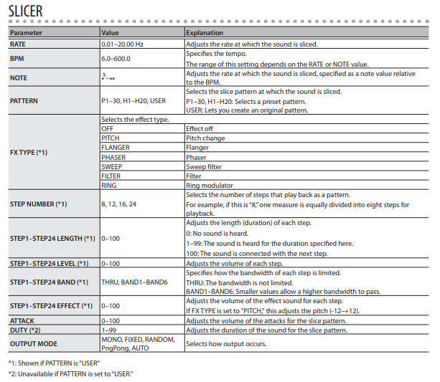  GT-1000:  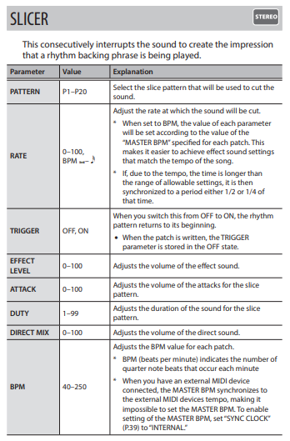
  Index | Parameter | Range of values (converted from Hex to Dec) | Description
  0 | PATTERN | 0 to 50 | Selects the slice pattern at which the sound is sliced.  0 to 29: SL-20 P01 to P30  30 to 49: SL-20 H1 to H20  50: user-defined pattern
  1 | SLICER | 0 to 1 | Setting this to 0 seems to turn slicing off.
  2 | FX TYPE [*1] | 0 to 6 | This is guesswork atm:  0: OFF  1: PITCH  2: FLANGER  3: PHASER  4: SWEEP  5: FILTER  6: RING
  3 | STEP NUMBER [*1] | 0 to 3 | Selects the number of steps that play back as a pattern. For example, if this is “8,” one measure is equally divided into eight steps for playback.  0: 8  1: 12  2: 16  3: 24
  4-27 (24) | STEP LENGTH [*1] | 0 to 100 | Adjusts the length (duration) of each step.  0: No sound is heard.  1–99: The sound is heard for the duration specified here.  100: The sound is connected with the next step
  28-51 (24) | STEP LEVEL | 0 to 100 | Adjusts the volume of each step.
  52-75 (24) | BAND | 0 to 6 | Specifies how the bandwidth of each step is limited.  0: THRU: The bandwidth is not limited. 1-6: BAND1–BAND6: Smaller values allow a higher bandwidth to pass.
  76-99 (24) | EFFECT | 0 to 100 | Adjusts the volume of the effect sound for each step.
  100-123 (24) | PITCH | 0 to 24 | Unlike the MD-500 which uses EFFECT to control the pitch effect I think the SL-2 uses these values.  I think values of 0 to 24 correspond to pitches -12 to +12 semitones around the input note.
SLICER(2) | 124
COMP | 7 | Compressor  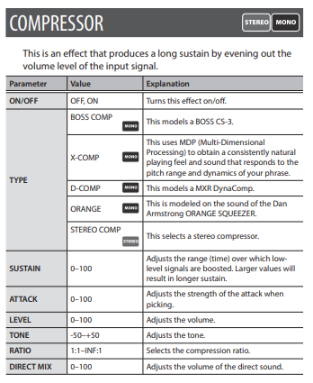
  Param | Description
  0 | 0 or 1, ON/OFF?
  1 | 7 to 100, SUSTAIN?
  2 | 0 to 80, ATTACK?
  3 | 15 to 60, LEVEL?
  4 | 40 to 69, TONE?
  5 | 4 to 17, RATIO?
  6 | 0 to 30, DIRECT MIX?
DIVIDER | 2 | Always 00, 09
PHASER(1) | 10 | 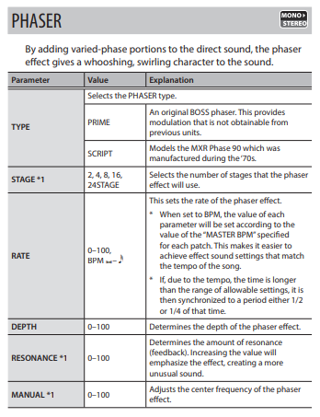  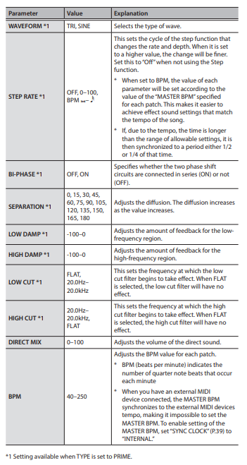
PHASER(2) | 10
FLANGER(1) | 11 | 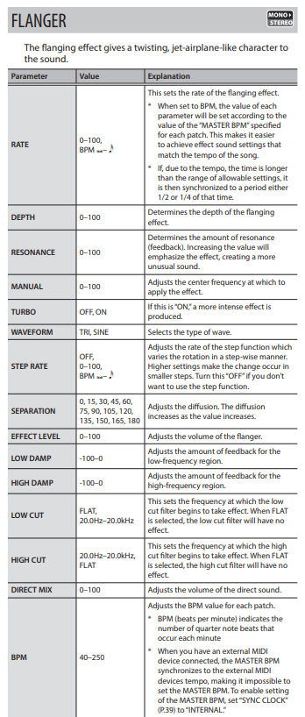
FLANGER(2) | 11
TREMOLO(1) | 6 | 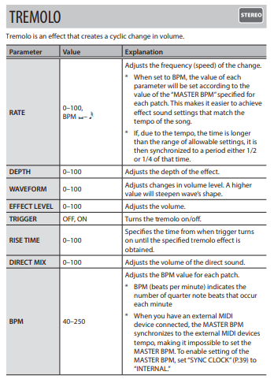
TREMOLO(2) | 6
OVERTONE(1) | 9 | 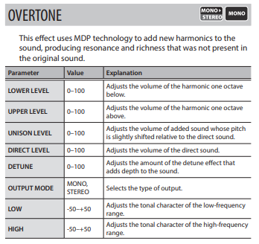
OVERTONE(2) | 9
MIXER | 5 | 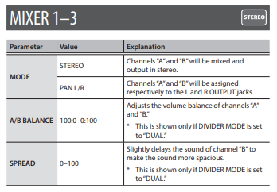
  Param | Description
  0 | 0 or 1, STEREO or PAN?
  1 | Always 1, A/B BALANCE?
  2 | 22 to 100, SPREAD?
  3 | 0 or 1
  4 | 18 to 100
NS | 3 | Noise Suppressor  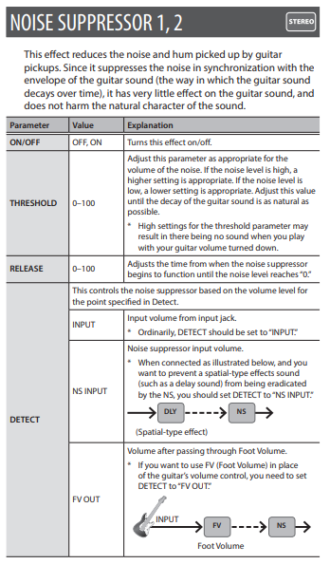
  Param | Description
  0 | Always set to 1, think this is ON/OFF
  1 | Ranges between 30 and 75, THRESHOLD?
  2 | Ranges between 10 and 34, RELEASE?
PEQ | 12 | Parametric Equaliser?  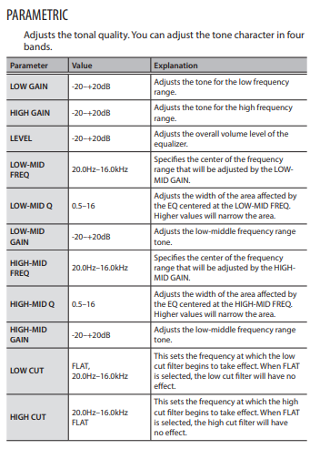
BEAT | 2 | Always “00”, “01”

